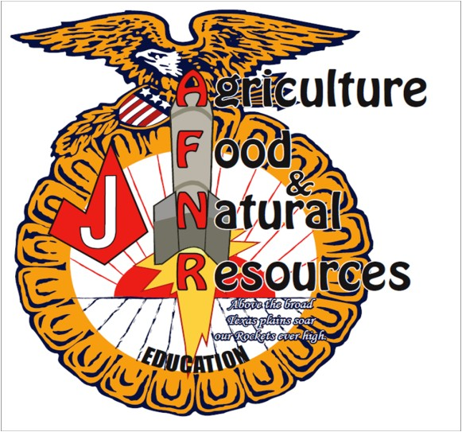

Judson Agriscience Program

2020-2021

Agriculture Science Instructors/Advisors

Mr. Jay Trees jtrees@judsonisd.org

Ms. Lauren Henderson lhenderson@judsonisd.org

Ms. Kelly Verstuyft kverstuyft@judsonisd.org

Mrs. Brittany Esparza
besparza@judsonisd.org

Ms. Sondra Lohse
slohse@judsonisd.org

Mrs. Kristin Rumfield
krumfield@judsonisd.org

Chapter Officers

PRESIDENT Sam Perez
VICE PRESIDENT Damien Luna
TREASURER Charla Wiemers PUBLICITY
Desi Mosemeyer
REC SECRETARY
Ja’Net Hayes
COOR SECRETARY
Becky Wilson
PROJECT COOR
Laura Bennet

Dear Supporter of the Judson FFA:

Each year we look for community minded businesses or individuals like you to support our youth involved in the Judson FFA program.

As a member of the Judson FFA Parent/Alumni Association, I am asking for donations for the Judson FFA Chapter Show on December 7, 2019.

The Chapter show’s primary purpose is to help the students learn how to present their projects and to gain valuable experience. The experience will prove helpful as they participate in the Bexar County Junior Livestock Show.

The donations we receive will be used to purchase the awards listed below. These awards will be presented to the winners of each animal breed as they showcase their animal project at the Judson FFA Chapter Show.

Sponsorship levels are:

$150.00 Grand Champions Award Buckle

$150.00 Reserve Grand Champions Award Buckle

$25.00 Rosette

Any donation you send will be greatly appreciated. Should you desire to sponsor a certain animal division (steer, goat, sheep, swine) please indicate that with your donation.

All sponsors will get advertising on our sponsor banner and will be recognized in our program and at our year-end banquet. Your donation to this organization will be tax deductible. The Judson FFA Alumni is a 501 © (3) organization, tax ID number 26-0133852.

Your donation can be made payable to Judson FFA Parent/Alumni, and mailed to:

Jay Trees, Judson High School, 9142 FM 78, Converse Texas 78109
OR given to any Alumni Board Member

If you have any questions, please contact:
JUDSONFFAALUMNI@gmail.com
Jay Trees @ 210-945-1100
Sam Perez @ 210-602-7502
Charla Wiemers @ 210-416-2018

On behalf of the Judson FFA Parent/Alumni Association, we thank you for your continued support of the youth of our community and hope to see you at the Chapter Show on December 7th.

Sincerely,
Sam Perez
Judson FFA Parent/Alumni Association President

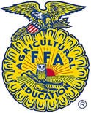

The FFA Mission

FFA makes a positive difference in the lives of students by developing their potential for premiere leadership, personal growth, and career success through agricultural education.

Est. 1959

9142 FM 78 Converse, TX 78109 • (210) 945-1100 ext. 19600 • Fax (210) 659-4359 • www.judson.ffanow.org

